Initial Program Load (IPL) Mainframe Procedure
Originator: | Sender De La Roca |  | Effective Date: | September 26, 2024
Manager Approval: | Sender De La Roca |  | Original Date: | September 26, 2024
 |  |  | Revision Date: | September 26, 2024
PURPOSE
The purpose of this procedure is to ensure a controlled and orderly IPL of the IBM Mainframe system, minimizing the risk of data loss and ensuring all subsystems are properly started.

PROCEDURES
NOTE: In this procedure, we will use the TECH LPAR as an example on how to IPL an LPAR in the IBM Mainframe.
The other two LPARS where this procedure will apply for are PROD and TEST.
- STARTUP
- AT the HMC Console:
- To IPL any LPAR, start with Groups icon
- Double Click on Groups
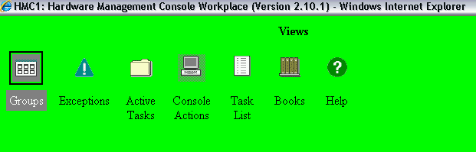
- After double clicked on Groups, you will see this: 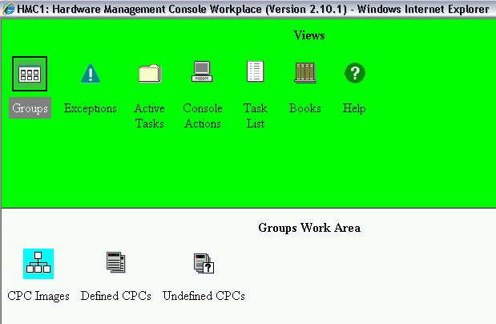
- On the screen above, double Click on CPC Images
- To work with TECH LPAR, point the mouse to (LACOE:TECH) LPAR and click once.
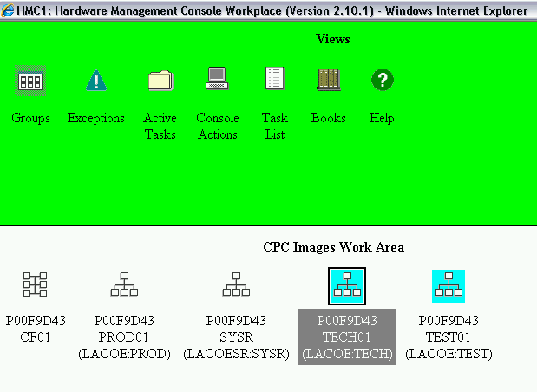
- Now, look at lower right corner, there are two symbols: 
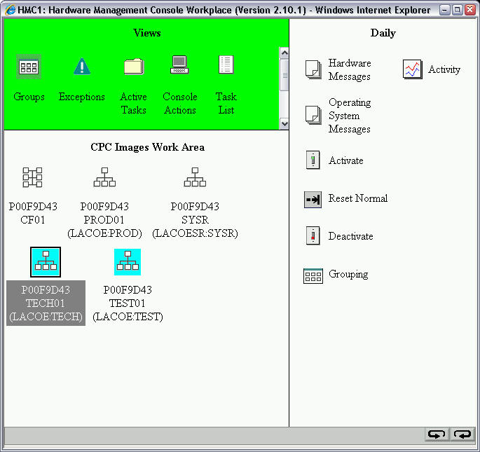
- Click on either symbols to scroll through the options on the right bar
- Look for the menu at your right for a screen call Recovery .
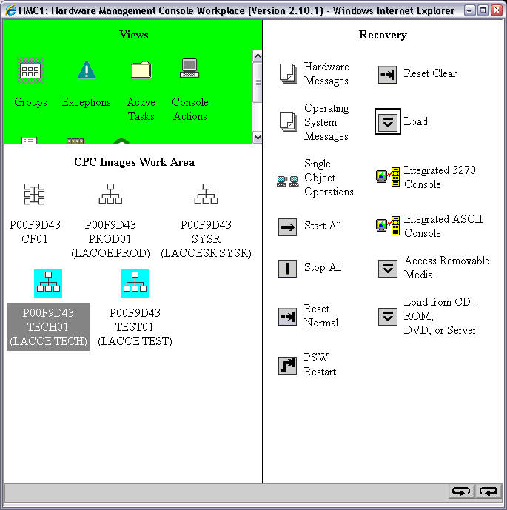
- Look for Load icon 
- Verify the highlighted LPAR on the left screen is the LPAR you intend to IPL,
- Once confirmed, double click on the LOAD icon on the right screen.
  - Use the same Load address and Load parameter already filled up.
  - If you were told to change the IPL address, Contact the MVS Support on call person if the address was not provided to you prior to this activity.

  - 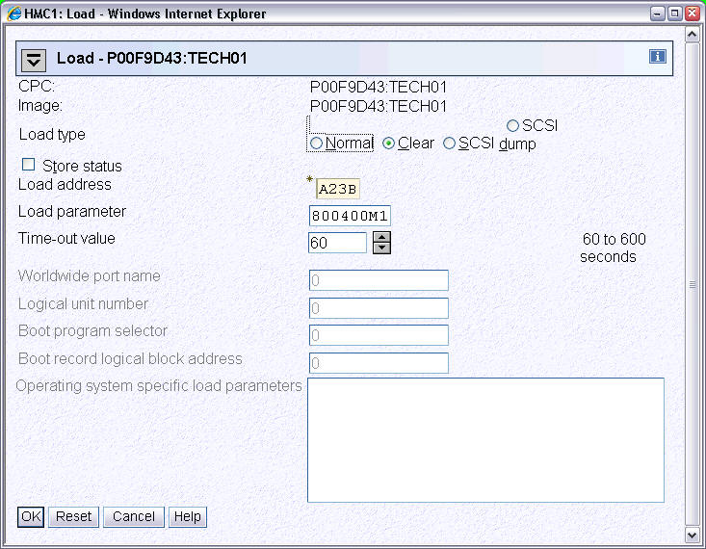
- Verify the screen above. At the Load Type option, check the Clear box
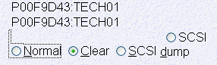
- Then at the lower left of the screen Click OK to continue with IPL
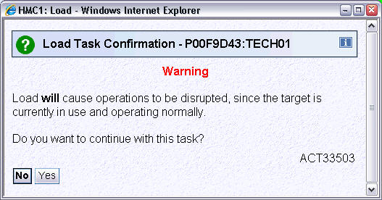

- Click YES to continue with IPL
- Enter the password for the id operator to confirm the IPL then click YES
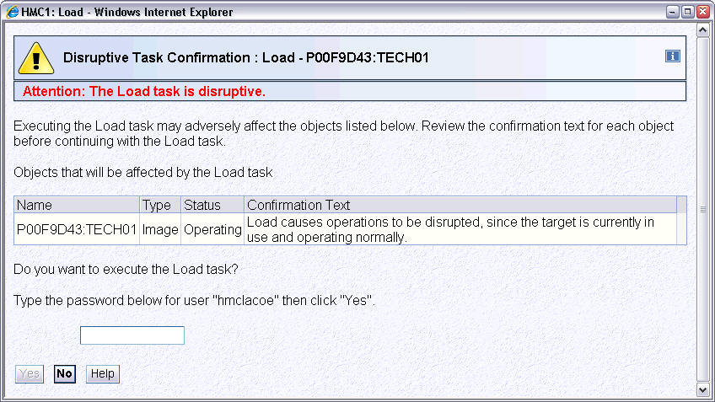
- After the password is entered and you click on YES, IPL process will begin.
- Everything will startup automatically in about four minutes.
- If the HMC console stops scrolling, issue this command:
- V CN(*),ACTIVATE
- Verify that these tasks have started by issuing a D A,L at the console:
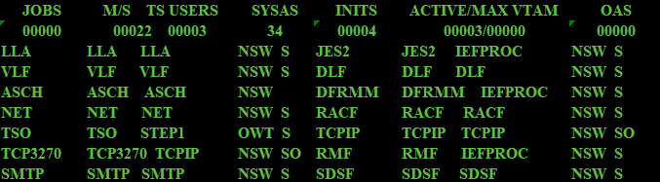
- Once these tasks are available, try to logon to TSO. If you are successful. The system was loaded properly.
- Any issues, escalate to the MVS support on-call person.

